Installation

Install Python

Step 1 : Visit https://www.python.org/

Windows 7 - Python 3.7
Windows 7 + (win 10 ) python 3.9
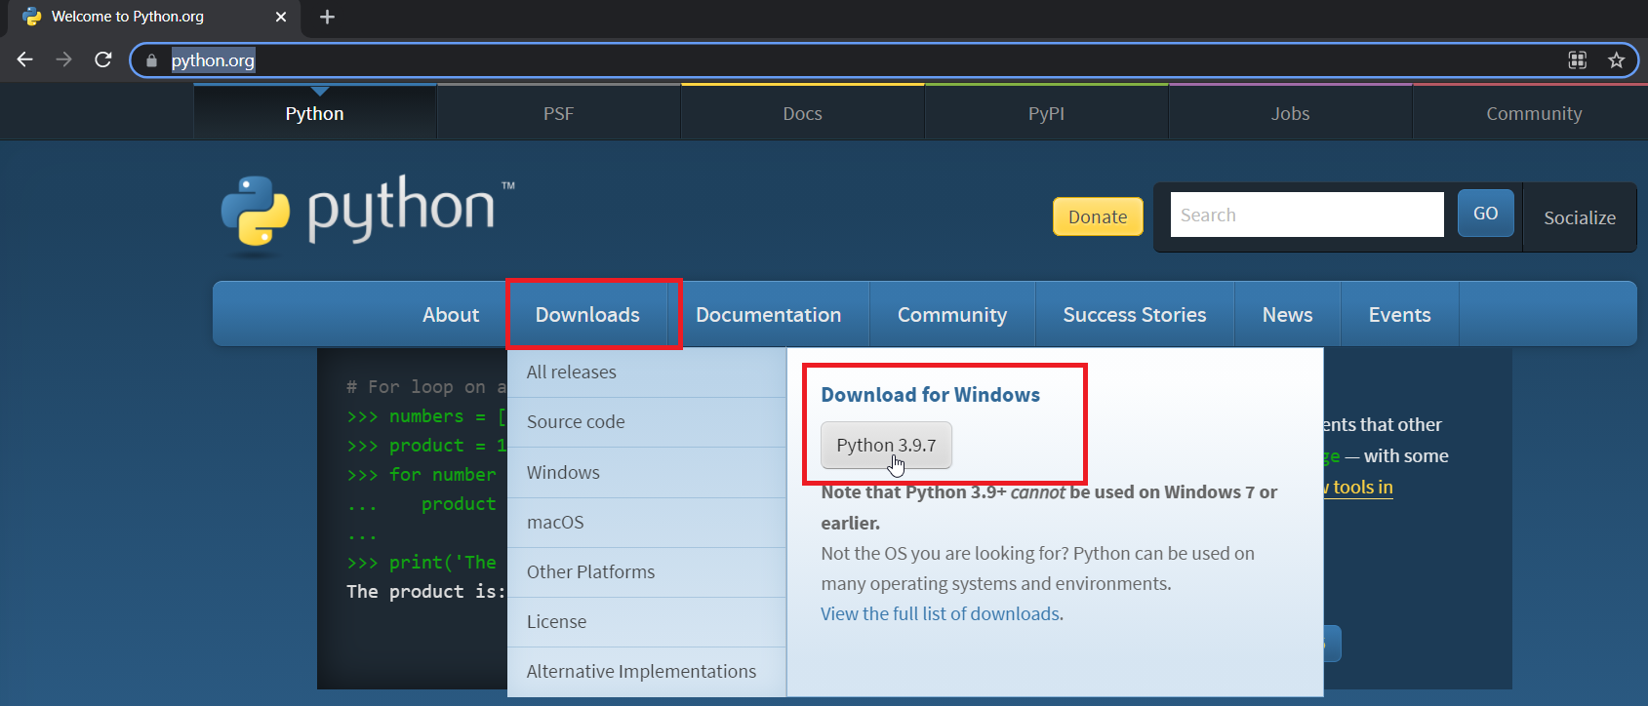
Step 2: Double click on downloaded exe and complete wizard.

Step 3: open Command Prompt and type Python and enter.
You should see some python version details installed on your machine.

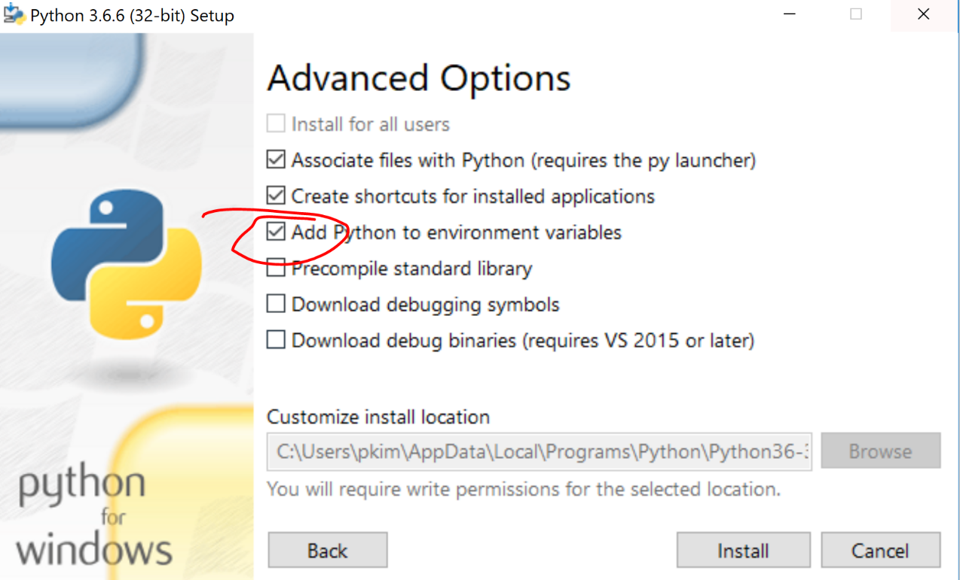

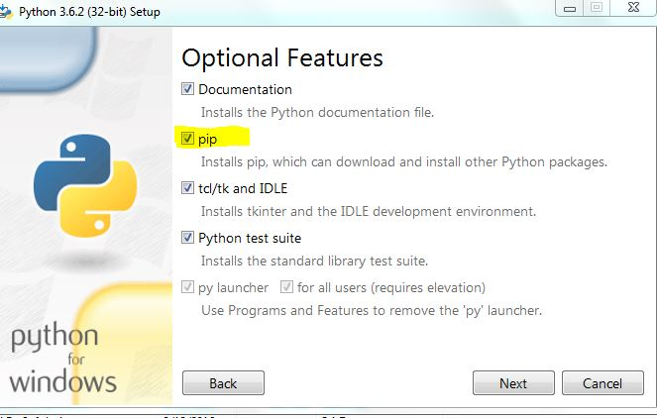

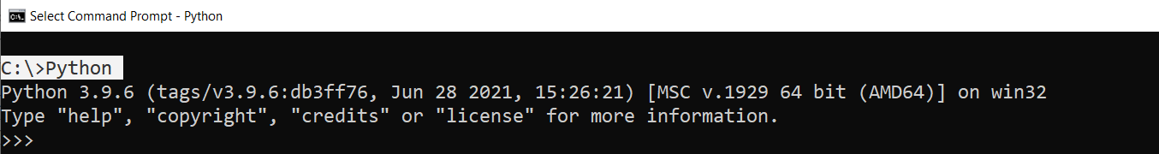
Note: exit from loop type exit() and enter

Install Selenium

Command: pip install –U selenium
Open Command prompt and type above command

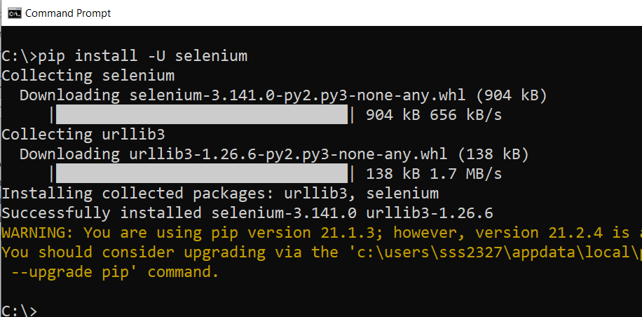

Step 2: verify with command pip list
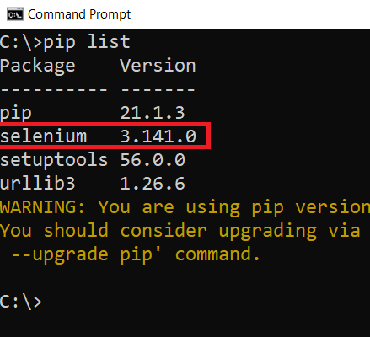

Install VS Code

Download executable from https://code.visualstudio.com/download

Selenium WebDriver download (Chrome, Firefox, and IE)

Install Pycharm and configure Selenium

Step 1 : Visit and download Pycharm community version from below URL
https://www.jetbrains.com/pycharm/download/#section=windows

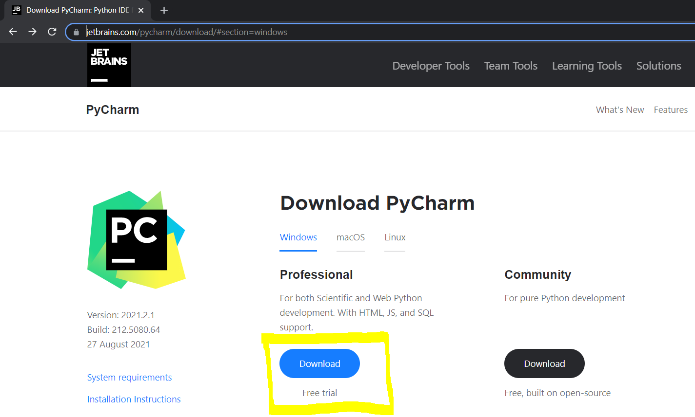

Step 2: Double click on downloaded exe and complete setup



Step 3: In installation wizard Select check boxes as below
